**Required Softwares to run Ruby scripts (for selenium automation) on windows7**

1. **Ruby 1.9.3 Installation**
2. **Ruby Devkit Installation**
3. **Install Google Chrome**
4. **Downloading “Chromedriver.exe”**
5. **Adding External extensions to Chrome and registering it.**
6. **Installing AutoIt and registering AutoIt DLLs**
7. **Installing Image Magick and setting the environment variables**
8. **Aptana IDE**
9. **Ruby 1.9.3 Installation**

For writing scripts in ruby you have to first install ruby on your windows system. You can pick the latest version of Ruby but you should make sure that all the other software is compatible with the installed version. Here at FactSet we use Ruby 1.9.3 as all the other software we are using are compatible with Ruby 1.9.3 version.

Though latest version of Ruby is Ruby 2.0.0 you can always download the older versions of it from the [ruby website](https://www.ruby-lang.org/en/downloads/).

You can download the ruby files as an archive too but it is recommended to download the installer when you are installing ruby on windows.

You can download Ruby installer for windows from [here](http://rubyinstaller.org/downloads/).

**Installation:**

* 1. After downloading Ruby1.9.3 installer double click on ruby installer file (.exe) and accept the download confirmation box (if appear) by hitting “Yes” button.
  2. Select the following three options as shown in the figure below and proceed with the installation:

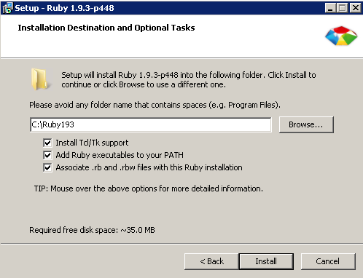

Click FINISH button after installation completes.

* 1. After the installation completes check if Ruby is installed. Follow the screenshot below to check if ruby is installed:

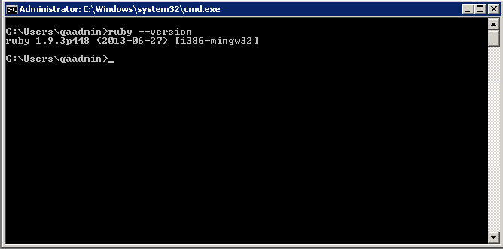

If ruby is installed successfully it’ll display the version number when you type “ruby --version” at command prompt.

1. **Ruby Devkit Installation**

**What is Devkit?**

Devkit is Development Toolkit for ruby installer that makes it easy to build and use native C/C++ extensions.

**About Ruby Gems:**

In other programming languages like JAVA we have different libraries to accomplish different tasks, we have [rubygems](http://rubygems.org/) in ruby. You can download these gems from “rubygems.org” based upon your needs.

To install any gem (on machine which do not have internet access), first download the gem file and run the following command from command prompt:

Ex: gem install C:\RubyGems\rubyzip-1.0.0.gem

To install gem (on machine having internet connection) use the following command:

Ex: gem install rubyzip

NOTE: Please download the gems which are compatible with the ruby version installed. If a particular gem gives you trouble while installing try the older version of same gem.

For complete help on ruby gems refer [this site](http://guides.rubygems.org/).

**DevKit Installation**

* 1. Download Devkitfrom [here](http://rubyinstaller.org/downloads/).

NOTE: Please download DEVKIT specific to the RUBY version you installed on your system.

* 1. After downloading Devkit place it in separate folder say “Devkit” under ruby installation directory i.e.,“C:\Ruby193”.
  2. Devkit file is an self-extractor file (you need to have zipping software installed on your system), after extracting the files run the following commands:

C:\Ruby193\Devkit>ruby dk.rb init

After running the above command a file will be created named – “config.yml”.

Now run:

C:\Ruby193\Devkit>ruby dk.rb install (Here install does not take more than 2 to 3 seconds)

After running the above commands Devkit path will be set.

For more details on Devkit installation refer [here](https://github.com/oneclick/rubyinstaller/wiki/Development-Kit).

1. **Install Google chrome**

At present we have FactSet extension created for Google Chrome which is required to communicate to FactSet Workstation. This is the main reason we are concentrating more on Google Chrome but in future we should be able to test against all the browsers.

You can download Google Chrome either directly from internet or download Chrome installer from [here](http://www.filehippo.com/download_google_chrome/51086/). (Select the appropriate version.)

1. **Downloading chromedriver.exe**

Chromedriver.exe is required to launch chrome instance through ruby for selenium testing.

For more info on why we need chromedriver.exe please [read here](http://www.seleniumhq.org/docs/03_webdriver.jsp#chrome-driver).

1. **Adding External extensions to Chrome and registering it.**

For chrome browser to communicate to FactSet Workstation developers have created an external extension for chrome which should be added to chrome.

To add the external extension to chrome follow the steps given below:

* 1. Download the external extensions (here, fds_chrome_ext.crx)
  2. Launch chrome browser
  3. Go to “chrome://extensions”
  4. Now drag the downloaded extension onto the chrome’s extension page.
  5. A popup appears asking for confirmation to add external extension. (Select “ADD” button)
  6. After extension is added, enable the extension if not already enabled.

Now you have to set path for external extension into the registry. Follow the instructions below:

For **WIN32** register FactSet's extension at "**HKLM\SOFTWARE\Google\Chrome\Extensions**"

For **WIN64**register FactSet's extension at "**HKLM\SOFTWARE\Wow6432Node\Google\Chrome\Extensions**"

NOTE: Create the keys if it does not exist.

FactSet Chrome extension's **ID:**cigjpdenknjbkiomlklhmigaekampbke

Create a key within Extensions folder and add two string values: a) **path** (path to the FactSet's chrome extension) b) **version:** 2012.5.596

Refer: <http://developer.chrome.com/extensions/external_extensions.html> for more info on how to register chrome extensions.

1. **Installing AutoIt and registering AutoIt DLLs**

AutoIt v3 is a freeware BASIC-like scripting language designed for automating the Windows GUI and general scripting. It uses a combination of simulated keystrokes, mouse movement and window/control manipulation in order to automate tasks in a way not possible or reliable with other languages (e.g. VBScript and SendKeys). AutoIt is also very small, self-contained and will run on all versions of Windows out-of-the-box with no annoying “runtimes” required!

Refer <http://www.autoitscript.com/site/autoit/> for AutoIt installation.

Set the **path** environment variable to “C:\Program Files (x86)\AutoIt3\AutoItX” (For 64 bit windows version) **or** “C:\ProgramFiles\AutoIt3\AutoItX” (For 32 bit windows version).

1. **Installing Image Magick and setting the environment variables**

 Install ImageMagick (download from <http://www.imagemagick.org/script/binary-releases.php#windows>) at "C:\" drive instead "C:\Program Files" (which is a default location).

NOTE: Please select the check box "Install development headers and libraries for C and C++" while installing ImageMagick.

After installing Image Magick set the following Environment variables:

Set DFImageMagick environment variable to where ImageMagick is installed (create new variable)

Set PATH=%DFImageMagick%;%PATH% (if you don't already have it in PATH)  
Set CPATH=%DFImageMagick%\include;%CPATH%  
Set LIBRARY_PATH=%DFImageMagick%\lib;%LIBRARY_PATH% (create new variable)

1. **APTANA IDE**

Aptana is open source development tool for the open web. It allows you to develop and test you entire web application using a single environment. It supports various languages such as HTML5, CSS3, JavaScript, Ruby, Rails, PHP and Python.

To download aptana [click here](http://www.aptana.com/products/studio3/download).

**Prerequisites**

Before you install APTANA you should have the following tools installed and working correctly.

* Ruby 1.8.7+ and/or 1.9.1+
* For debugging, you will need to have the “**ruby-debug-base**” and “**ruby-debug-ide**” gems installed.

After downloading Aptana Studio3 install it with the default options selected (you can change the default installer location if you want).

To learn more about Aptana Studio 3 [click here](https://wiki.appcelerator.org/display/tis/Home) (Don’t get confuse if you see TITANIUM STUDIO).

**Get Started**

* Start going through the basics of Ruby Scripting language.

**Ruby Learning links**

* + <http://rubylearning.com/>
  + <http://glasnost.itcarlow.ie/~barryp/ruby-tut.html>
  + <https://github.com/bbatsov/ruby-style-guide> (For Ruby General Conventions)
  + <http://rubymonk.com/>
  + <http://www.tutorialspoint.com/ruby/>
  + <http://www.codecademy.com/tracks/ruby>
  + <https://www.ruby-lang.org/en/documentation/>
* Go through the basics of Selenium.

**Selenium learning links**

* + <http://www.questionselenium.com/>
  + <http://www.seleniumhq.org/docs/02_selenium_ide.jsp>
  + <http://assertselenium.com/>